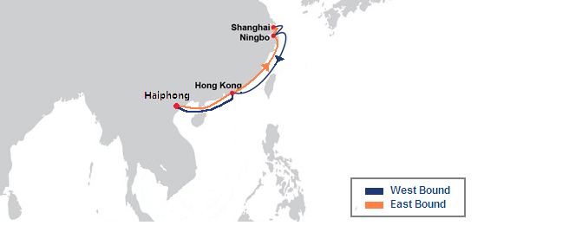
2
Hong kong
7
4
Ningbo
6
3
Shanghai
Haiphong
Hong Kong
From / To
HHX1 West Bound
3
6
Ningbo
4
Hong Kong
7
2
Haiphong
Shanghai
Hong Kong
From / To
HHX1 East Bound
HHX1 - Hong Kong Haiphong Express Service

Port Rotation
Ningbo - Shanghai - Hong Kong – Haiphong – Hong Kong – Ningbo - Shanghai
Transmit Time (Day)
Transmit Time shown in this PDF file may differ from actual time.

